Sunrise and Sunset Times Project Proposal
Developer: Michelle Chua
Target Audience: Travelers, hikers, and anyone who works outdoors
Technology Stack: Python, Dash, Plotly, Sunrise Sunset API, Geocoding API
Background
This project proposes the development of an interactive application that provides the time for sunrise and sunset if given a city. The app will use the Sunrise Sunset API to retrieve and provide the accurate time for sunrise and sunset of the current day. With this data, the app will also provide the total length of day and how much time there is until the first or last light, depending on which is closer.
Business Problem
Weather apps provide weather conditions, but one must scroll to find the time for sunrise and sunset. Furthermore, the length of day and the time to first or last light are not easily obtained with standard weather apps. This is useful information for travelers, hikers who would like to hike during daylight hours, and workers who need to plan their day so they can schedule their daylight-dependent tasks.
Objectives
- Create a sunrise and sunset application using Dash
- Allow users to search for sunrise and sunset times by city
- Provide the total duration of daylight for the selected city
- Display the amount of time remaining until first or last light
- Support outdoor planning and daylight-dependent scheduling
- If the last light for the current day has already occurred, the app will provide the next day’s information.
Methodology
- API or data source - https://sunrise-sunset.org/api
- Tools and technologies
  - Python
  - Dash
  - Plotly
- ETL workflow design
  - Extract
    - User enters city name
    - Geocoding API uses the city name to retrieve latitude and longitude coordinates
    - Use coordinates to obtain sunrise & sunset times and daylight duration from Sunrise Sunset API
  - Transformation
    - Convert UTC timestamps to local time
    - Convert day_length to hours:minutes:seconds
    - Calculate
      - First light
      - Last light
      - Time to each
  - Load - cleaned data will be loaded/stored into Pandas DataFrames
- Visualization strategy
  - The dashboard will be made using Dash and Plotly to create interactive and user-friendly displays
  - Planned dashboard features
    - Sunrise and sunset times in display box
    - Daylight duration in hours:minutes:seconds (also in display box)
    - Next event (either first or last light) in display box
    - Time until the next event (also in display box)
    - Bar charts showing the amount of daylight hours for the current day and the time until the next solar event
- Process flow chart/ETL Architecture Diagram
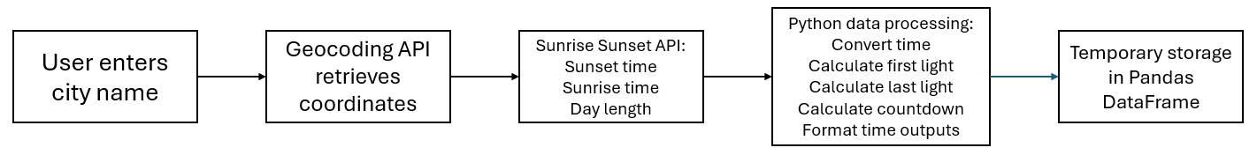Timeline
Week | Tasks
Week 1 | Select topic and API, research topic, and draft proposal
Week 2 | Learn to use Sunrise Sunset API, integrate in Geocoding API, retrieve sunrise & sunset data and day length, figure out conversions
Week 3 | Figure out calculations and start building dashboard
Week 4 | Continue/finalize interactive and user-friendly dashboard
Week 5 | Test dashboard, prepare presentation, and submit assignment
Expected Outcomes
- Sunrise Sunset and Geocoding API integration
- Working ETL pipeline that will:
  - Extract data from APIs
  - Transform timestamps
  - Calculate time until first and last light
  - Load processed data into a useable format for visualization
- Interactive and user-friendly dashboard that will:
  - Allow users to input their city of interest
  - Show the times for sunrise and sunset
  - Display the length of day in a clear, readable format
  - Show the time until first or last light
  - Update automatically if a new city is input

